# CS 255 System Design Document Template

## UML Diagrams

### UML Use Case Diagram

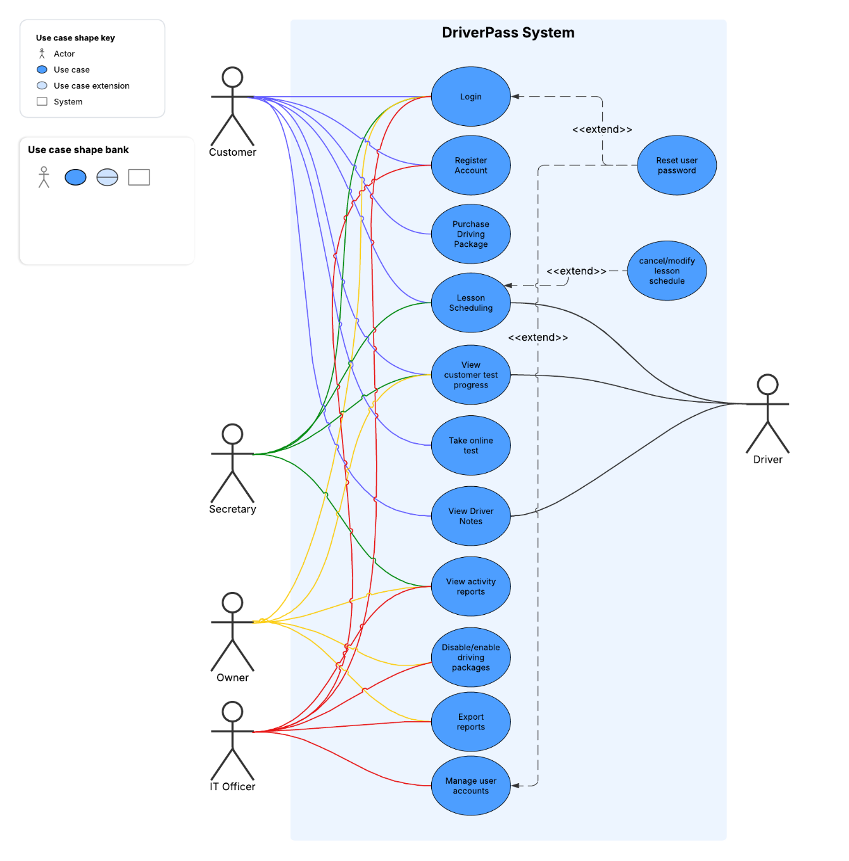

### UML Activity Diagrams

Activity diagram for login:

Activity diagram for Scheduling:

### UML Sequence Diagram

sequence diagram for Scheduling a driving lesson:

### UML Class Diagram

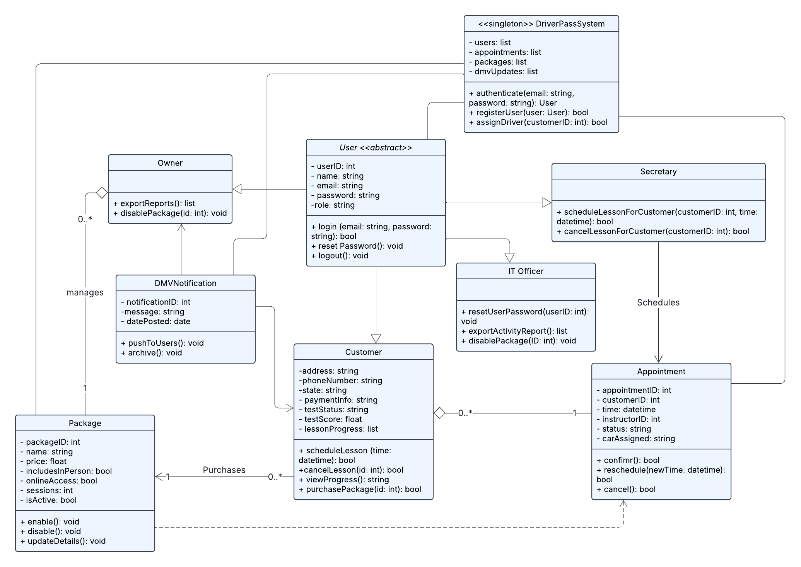

## Technical Requirements

* The system uses an object-oriented design with a DriverPassSystem class managing users, appointments, packages, and notifications.
* The User class is abstract and extended by roles like Customer, Secretary, Owner, and IT Officer. Each role has specific capabilities like scheduling lessons, managing accounts, or exporting reports.
* Customers can register, log in, buy driving packages, and schedule or cancel lessons. Admin roles manage user accounts, packages, and system data.
* Login and lesson scheduling are illustrated with activity and sequence diagrams, showing step-by-step flows for user interaction and system checks.
* The use case diagram outlines available actions for each actor, including extended functionality like password resets and lesson cancellations.
* The class diagram shows how system entities are connected, including users, appointments, and driving packages.